ESP-01 Pinout

This document describes the pinout of the ESP-01 board and how these pins are used withing the code.

Inhoudsopgave
ESP-01 Pinout 1
Pinout of the board 2
More information 3

Pinout of the board

The board used is an ESP-01, which features an ESP8266 microcontroller.
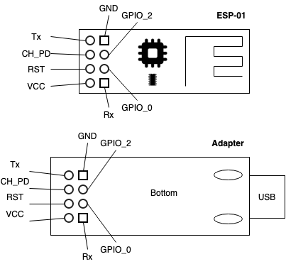
The ESP-01 has a limited number of pins which can be used. By default GPIO0 and GPIO2 are used as regular I/O, while Tx/Rx are used for serial communication (the debug console).

If no peripherals (other than the NeoPixels are used, only GPIO2 is used.

Later versions of this unit will re-configure the Tx/Rx to be I2C pins:
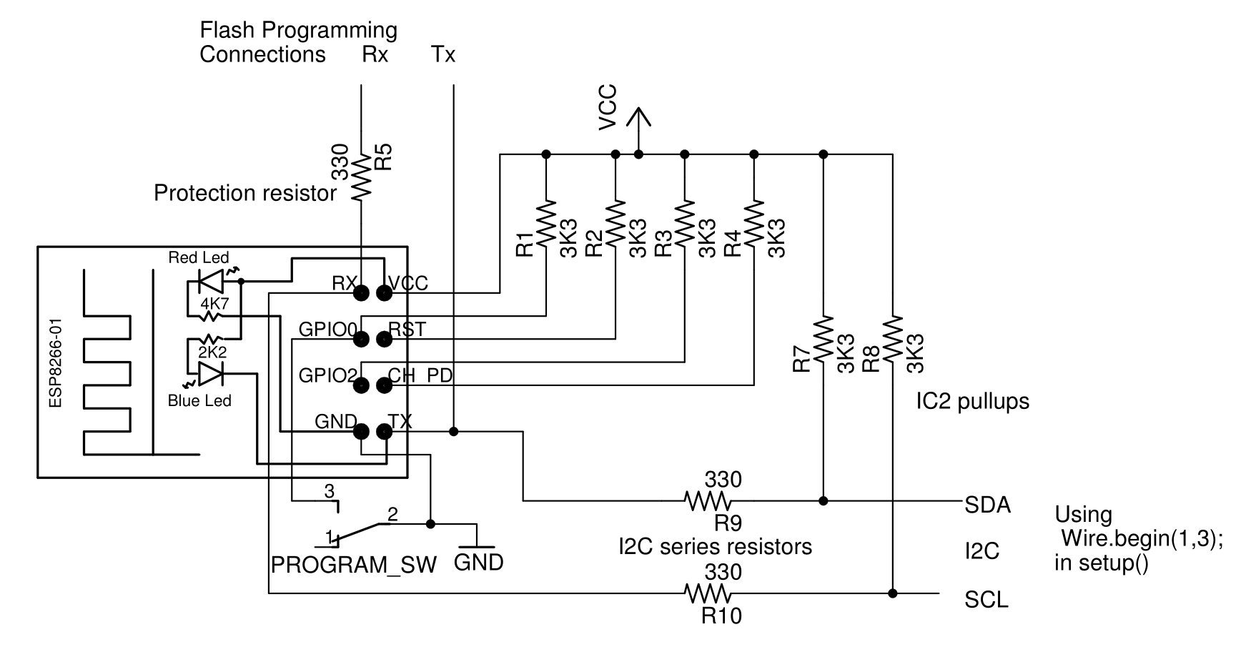

More information
More information about the board can be found here:
https://www.electroschematics.com/the-mighty-esp-01-adapter/
https://medium.com/@aallan/getting-started-with-the-esp8266-270e30feb4d1
https://www.instructables.com/id/Getting-Started-With-the-ESP8266-ESP-01/

Programming with USB-programmer (Dutch)
https://opencircuit.nl/Blog/Simpele-ESP-01-Programmer-hack

Pins and how to connect things
https://www.forward.com.au/pfod/ESP8266/GPIOpins/ESP8266_01_pin_magic.html
https://randomnerdtutorials.com/esp8266-pinout-reference-gpios/

